Questions of final exam on discipline
MZiB2216 "Mechanisms of Defense and Disease (medical genetics, microbiology, pharmacology)" - 10 ECTS

Final exam questions for Genetics

Option 1
J.L., a healthy 16-year-old high school basketball star, was referred to the genetics clinic for evaluation for Marfan syndrome. His physique was similar to that of his father. His father, a tall, thin man, had died during a morning jog; no other family members had a history of skeletal abnormalities, sudden death, vision loss, or congenital anomalies. On physical examination, J.L. had an asthenic habitus with a high arched palate, mild pectus carinatum, arachnodactyly, arm span-height ratio of 1.1, diastolic murmur, and stretch marks on his shoulders and thighs. He was referred for echocardiography, which showed dilatation of the aortic root with aortic regurgitation. An ophthalmological examination showed bilateral iridodonesis and slight superior displacement of the lenses. Based on his physical examination and testing results, the geneticist explained to J.L. and his mother that he had Marfan syndrome.
Figure 1. Pea ectopia.
Phenotype- Gene Relationships
Location | Phenotype | Phenotype  MIM number | Inheritanse | Gene/Locus | Gene/Locus MIM number
15q21.1 | Marfan syndrome | 154700 | AD | FBN1 | 134797
Figure 2. OMIM database: Information about Marfan syndrome.

Questions:
1. What is the epidemiology and prevalence rate of Marfan syndrome?
2. Explain the basic genetic data / symptoms given for this disease in OMIM (Figure 2)
3. Why does the effect of a mutation in one gene (FBN1) lead to changes in several body organ systems? What is the term used for the explanation effect of one gene on several traits?
4. What diagnostic methods are used in Marfan syndrome?
5. Propose methods of treatment for Marfan's syndrome. What advice would you give Andrea about playing basketball based on the diagnosis?

Option 2
Jessika Robins was born at 38 weeks' gestation after an uncomplicated pregnancy and delivery. She was the second child of nonconsanguineous parents. Shortly after birth, her parents and the nurses noticed that she was hypotonic and feeding poorly. Her parents and older sister were in good health; she did not have a family history of neuromuscular, developmental, genetic, or feeding disorders. Review of the medical record did not reveal a history of overt seizures, hypoxic insults, infection, cardiac abnormalities, or blood glucose or electrolyte abnormalities. On examination, J.T. did not have respiratory distress or dysmorphism; her weight and length were appropriate for gestational age; she was severely hypotonic with lethargy, weak cry, decreased reflexes, and a poor suck. Subsequent evaluation included testing for congenital infections and congenital hypothyroidism; measurements of blood ammonium, plasma amino acids, and urine organic acids; chromosomal microarray; and methylation testing for the Prader-Wiiii/Angelman region on 15q11-13. The results of the methylation testing showed an abnormal methylation pattern consistent with Prader-Willi syndrome (one hypermethylated copy of SNRPM. and the chromosomal microarray revealed a deletion on chromosome 15q11-q13. The geneticist explained to the parents that J.T. had Prader-Willi syndrome. After much discussion and thought, J.T.'s parents decided that they were unable to care for a disabled child and gave her up for adoption.
Phenotype- Gene Relationships
Location | Phenotype | Phenotype  MIM number | Inheritanse | Gene/Locus | Gene/Locus MIM number
15q11.2 | Prader-Willi syndrome | 176270 | AD | NDN | 602117
Figure 1. OMIM database: Information on Prader-Willi syndrome.
Questions:
1. What are the main causes of this disease?
2. Explain the basic genetic information for this disease in OMIM (Figure 1)
3. Determine the place of this disease in the classification of hereditary diseases.
4. Write the probably mechanism of mutations in this disease in general
5. Write legal and ethical issues regarding Jessica and her parents. If you were consulting this family as a genetic counselor, what advice would you give to Jessica's parents?

Option 3.
Pamela Slowsborry, a 30-year-old healthy woman was 27 weeks pregnant with her first child. A fetal ultrasound examination at 26 weeks' gestation identified a female fetus with macrocephaly and rhizomelia (shortening of proximal segments of extremities). P.S.'s spouse was 45 years of age and healthy; he had three healthy children from a previous relationship. Neither parent has a family history of skeletal dysplasia, birth defects, or genetic disorders. The obstetrician explained to the parents that their fetus had the features of achondroplasia. The infant girl delivered at 38 weeks' gestation by cesarean section. She had the physical and radiographic features of achondroplasia, including frontal bossing, megalencephaly, midface hypoplasia, lumbar kyphosis, limited elbow extension, rhizomelia, trident hands, brachydactyly, and hypotonia. Consistent with her physical features, DNA testing identified an 1138G>A mutation leading to a glycine to arginine substitution at codon 380 (Giy380Arg) in the fibroblast growth factor receptor 3 gene (FGFR: JJ.)
Questions:
1. What are the main features of inheritance patterns of the genetic group where Achondroplasia belongs?
2. What is the epidemiology and prevalence rate of Achondroplasia?
3. Write the mechanism of achondroplasia's development. What are the risk factors for the development of achondroplasia in Pamela's daughter?
4. Develop a strategy to assess the risk of having a sick child in Pamella's family.
5. Write ethical and legal issues related to the treatment of the disease in general / the situation presented in this case.

Option 4
Louis Corey, a previously healthy 45-year-old French Canadian poet, was admitted for a myocardial infarction. He had a small xanthoma on his right Achilles tendon. His brother also had coronary artery disease (CAD); his mother, maternal grandmother, and two maternal uncles had died of CAD. In addition to his family history and sex, his risk factors for CAD and atherosclerosis included an elevated level of low-density lipoprotein (LDL) cholesterol, mild obesity, physical inactivity, and cigarette smoking. Based on family history, L.L. was believed to have an autosomal dominant form of hypercholesterolemia. Molecular analysis revealed that he was heterozygous for a deletion of the 5' end of the LDL receptor gene (LDLR), a mutation found in 59% of French Canadians with familial hypercholesterolemia. Screening of his children revealed that two of the three children had elevated LDL cholesterol levels. The cardiologist explained to L.L. that in addition to drug therapy, effective treatment of his CAD required dietary and lifestyle changes, such as a diet low in saturated fat and low in cholesterol, increased physical activity, weight loss, and smoking cessation. L.L. was not compliant with treatment and died a year later of a myocardial infarction.
Figure 1. Achilles tendon xanthoma in a patient with familial hypercholesterolemia

Questions:
1. What is the epidemiology and prevalence rate of Family hypercholesterolemia? Why is this type of mutation especially prevalent in the Canadian French population?
2. Write about the main causes leading to this disease.
3. Which group of genetic diseases belongs to Family hypercholesterolemia?
4. Write the religious, cultural, social, and ethical beliefs that may influence the decision of the patient and his or her family.
5. What is the risk level for Louis children to get sick from familial hypercholesterolemia? Explain your answer.

Option 5
A doctor examined a 39-year-old patient named Mary. She complains of fatigue, chest tightness and pain. Since the nodule palpated in the patient’s chest during the examination, she was sent for mammography. Mammography results showed an abnormal condition (Figure 1). At the next appointment, the doctor will send Maria to a specialized comprehensive diagnostic and treatment center for further examination. He explained to Maria the importance of a biopsy. The result of the biopsy revealed an invasive breast cancer. From the anamnesis: Start of menstruation: 10 years. Beginning of sexual activity: 29 years. A family history of breast cancer is unknown. Only her mother’s sister died at the age of 40. Mary does not know the cause of death. She only remembers that her aunt was sad before his death. Maria is a single mother of three children. Now their children are 14, 9 and 7 years old. All children under the age of 1 year received artificial nutrition. For the past 6 years, Mary has been working as a cashier in a store. She lives in a rented apartment with her elderly mother and children. Mary also attends a Christian church every Sunday. A year ago, she noticed a lump in her chest and told the priest. The priest advised her not to see a doctor, and explained to her that all this was due to sin and that she should offer prayers only to God.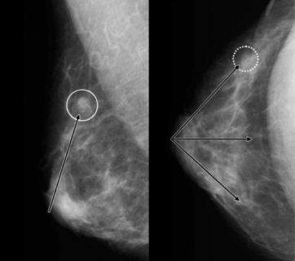
Figure 1. The results of Mary's mammographic examination.

Questions:
1. What are the risk factors for Mary? What other carcinogenic factors do you know?
2. What are the main features of inheritance patterns of this disease?
3. Write about the probable mechanism of mutations in this case.
4. Which group of genetic diseases belongs to this case?
5. Write the religious, cultural, social, and ethical beliefs that may influence the decision of the patient.

Option 6
4-year-old Wood Audley and her mother referred to a geneticist. From the anamnesis, she registered in the dispensary for the following diseases: “Congenital heart defects of the interventricular septum. Inhibition of psychomotor development. Secondary chronic pyelonephritis (against the background of doubling of the left kidney). Recurrent bronchitis. Bilateral chronic otitis”. Wood's mother was 38 years old at the time of the 6th pregnancy, the 5th childbirth (1 healthy child in the family - 10 years old, the 2nd pregnancy - the birth of a stillborn child, 2 pregnancies ended in spontaneous abortion). Child examination: mongoloid cornea, microcephaly, masculine nose, small teeth; increased range of motion of the joints. The doctor referred to the geneticist karyotyping.
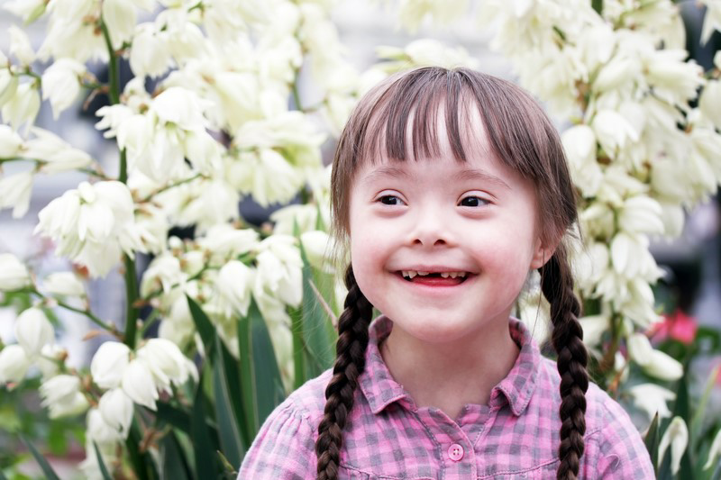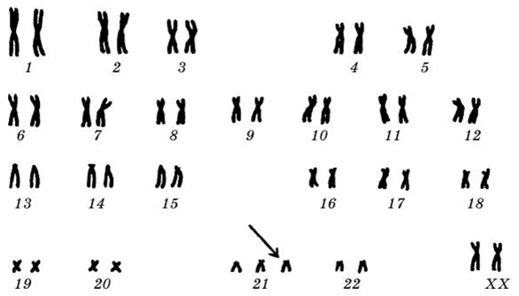
Figure 1. 4-year-old Wood. Figure 2. Karyotype

Questions:
1. What is the diagnosis? Write to which group of genetic diseases belongs this case.
2. Describe the results of the karyotype presented in Figure. Describe the mechanism of this mutation.
3. What genetic variants of this disease do you know?
4. What risk factors can contribute to the development of this disease?
5. Propose methods of diagnosis and treatment for this disease and explain your strategy.
Option 7
A 2-month-old boy admitted to the hospital with a suspected congenital heart defect (ventricular septal defect).The mother complains of low appetite (4 times less weight in the last month), lack of fixation of vision, anxiety. From the anamnesis: Mother is 23 years old. Child was born against the background gestosis, 2nd pregnancy, weighing 2130 g, height 46 cm. During her mother's first pregnancy, she gave birth to a healthy baby girl.
Examination of child: dolichocephalic shape of the skull, microgenia, umbilical hernia. Symptoms of muscular hypotension, dysplasia of the pelvic joints. Karyotyping performed.
Result of karyotyping:
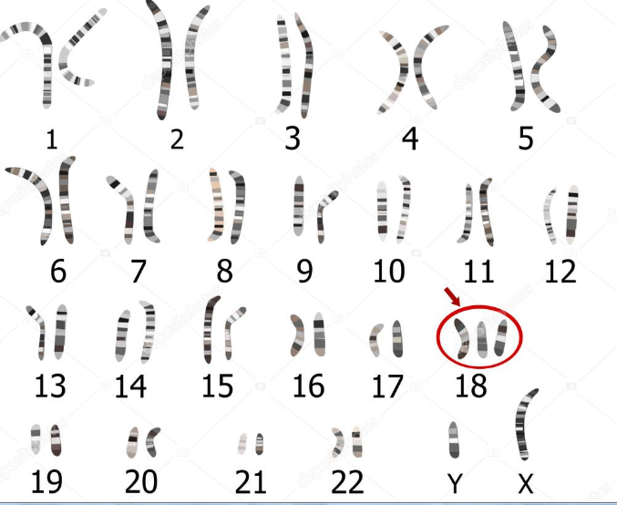

Questions:
1. What is the diagnosis? What are the main causes of this disease?
2. Describe the results of the karyotype presented in Figure. Describe the mechanism of this mutation.
3. What is the epidemiology and prevalence rate of this disease?
4. Which group of genetic diseases belongs to this case?
5. Propose methods of diagnosis and treatment for this disease and explain your strategy.

Option 8
Nicole Fieber came to the pediatric clinic with her 6-month-old baby. She complained of skin rashes and cramps of the child that appeared twice in the last day. The mother explains the appearance of a skin rash by adding red apples to the diet. From the anamnesis: a child born to healthy young parents. Pregnancy and childbirth were normal, body weight at birth 3200 g. On examination: the body is in good shape, the development of subcutaneous fat is weak, the skin is pale, and signs of eczema appear on the skin of the face, forearm, and calf. His hair is light and thin, and his eyes are blue. The attitude is careless, does not respond to the doctor’s emotional speech, disturbing actions. The child has nystagmus. Lying inside, he holds his head poorly. Weak legs. Decreased muscle tone. The child smells of an unpleasant "mouse" Tendon reflexes are high. However, sensitivity persists. For diagnostic purposes, a drop of Felling reagent was applied to the diaper containing the urine of the child, which caused the appearance of green pigment.
Questions:
1. What is the diagnosis? What is the epidemiology and prevalence rate of this disease?
2. What are the main features of inheritance patterns of this disease?
3. Which group of genetic diseases belongs to this case?
4. Explain the probably mechanism of mutations in this case
5. Suggest a strategy for the prevention and treatment of this disease.

Option 9
Betty Tomas, a healthy 38-year-old woman, scheduled an appointment for counseling regarding her risk for having a child with hemophilia. She had a maternal uncle who had died in childhood from hemophilia and a brother who had had bleeding problems as a child. Her brother's bleeding problems had resolved during adolescence. No other family members had bleeding disorders. The geneticist explained to Betty that her family history was suggestive of an X-linked abnormality of coagulation such as hemophilia A or B and that her brother's improvement was particularly suggestive of the hemophilia B variant factor IX Leyden. To confirm the diagnosis of hemophilia, the geneticist told Betty that her brother should be evaluated first because identification of an isolated carrier is difficult. Betty talked to her brother, and he agreed to an evaluation. Review of his records showed that he had been diagnosed with factor IX deficiency as a child but now had nearly normal plasma levels of factor IX. DNA mutation analysis confirmed that he had a mutation in the F9 gene promoter, consistent with factor IX Leyden. Subsequent testing of Betty showed that she did not carry the mutation identified in her brother.
Questions:
1. Explain which group of genetic diseases belongs to this case.
2. What is the epidemiology and prevalence rate of Hemophilia in the world?
3. Propose and explain risk assessment strategy for this disease.
4. What are the main features of inheritance patterns of a group of diseases that belong to Hemophilia?
5. Propose and explain strategies for assessing the risk of having a sick child for the Betty and her brother families’ separately.

Option 10.
Andrew Smith, a 6-year-old boy, referred for mild developmental delay. He had difficulty climbing stairs, running, and participating in vigorous physical activities; he had decreased strength and endurance. His parents, two brothers, and one sister were all healthy; no other family members similarly affected. On examination, he had difficulty jumping onto the examination table, a Gowers sign (a sequence of maneuvers for rising from the floor; proximal weakness, a waddling gait, tight heel cords, and apparently enlarged calf muscles. His serum creatine kinase level was 50-fold higher than normal. Because the history, physical examination findings, and elevated creatine kinase level strongly suggested a myopathy, Andrew referred to the neurogenetics clinic for further evaluation. Results of his muscle biopsy showed marked variation of muscle fiber size, fiber necrosis, fat and connective tissue proliferation, and no staining for dystrophin. Based on these results, Andrew was given a provisional diagnosis of Duchenne muscular dystrophy, and he was tested for deletions of the dystrophin gene; he was found to have a deletion of exons 46 through 48. Subsequent testing showed his mother to be a carrier. The family was therefore counseled that the risk for affected sons was 60o/o, the risk for affected daughters was low but dependent on skewing of X inactivation, and the risk for carrier daughters was 50%. Because her carrier status placed her at a high risk for cardiac complications, the mother referred for a cardiac evaluation.
Question:
1. What are the main causes of this disease?
2. Write to which group of genetic diseases belongs this case.
3. What are the main features of the hereditary patterns of diseases belonging to this genetic group?
4. Write the probable mechanism of mutations Duchene muscular dystrophy.
5. Propose and explain a risk assessment strategy for all members of Andrew Smith's family.

Option 11.
Mark Robs, a 45-year-old man, presented initially with declining memory and concentration. As his intellectual function deteriorated during the ensuing year, he developed involuntary movements of his fingers and toes as well as facial grimacing and pouting. He was aware of his condition and became depressed. He had been previously healthy and did not have a history of any similarly affected relatives; his parents had died in their 40s in an automobile accident. M.P. had one healthy daughter. After an extensive evaluation, the neurologist diagnosed Mark's condition as Huntington disease. The diagnosis of Huntington disease was confirmed by a DNA analysis showing 43 CAG repeats in one of his HD alleles (normal, <26). Subsequent presymptomatic testing of M.P.'s daughter showed that she had also inherited the mutant HD allele (Fig). Both received extensive counseling.
Questions:
1. Write about the main causes of this disease.
2. What are the hereditary features of Huntington's disease? Why is Mark's daughter healthy with this mutation?
3. What is the epidemiology and prevalence rate of this disease?
4. Which group of genetic diseases belongs to this condition?
5. Compare and contrast the pathological mechanisms of Huntington's disease and correlate them with clinical presentation.

Option 12.
Alex Joseph, a 45-year-old father with late-onset diabetes mellitus, was referred to the genetics clinic for counseling regarding his children's risk for diabetes. Alex developed glucose intolerance (inability to maintain normal blood glucose levels after ingestion of sugar) at the age of 39 years and fasting hyperglycemia at 45 years. He did not have a history of other medical or surgical problems. The findings from his physical examination were normal except for moderate abdominal obesity; his body mass index (weight in kilograms/(height in meters)2) was 31.3, with the excess adiposity distributed preferentially around his waist. He had five children by two different partners; a child from each relationship had developed insulin-dependent (type 1) diabetes mellitus (IDDM) before 10 years of age. His sister developed IDDM as a child and died during adolescence from diabetic ketoacidosis. The geneticist explained that given his family history, Alex might have a late-onset form of IDDM and that his current, nonInsulin-dependent diabetes mellitus was probably an antecedent to the development of IDDM. After discussing the possible causes of and prognostic factors for the development of IDDM, Alex elected to enroll himself and his children, who were all minors, in a research protocol studying the prevention of IDDM. As part of that study, he and his children were tested for anti-islet antibodies. Both he and an unaffected daughter had a high titer of anti-islet antibodies; the daughter also had an abnormal glucose tolerance test result but not fasting hyperglycemia. As part of the study protocol, Alex and his daughter were prescribed low-dose insulin injections.
Questions:
1. What are the main causes leading to Diabetes mellitus 1 Type?
2. What is the epidemiology and prevalence rate Diabetes mellitus?
3. Propose and explain risk assessment strategy diabetes in Alex's children.
4. Which group of genetic diseases belongs to this condition?
5. Propose methods of diagnosis, prevention, treatment of this condition, and explain your strategy.

Option 13.
John Tills, a 6-year-old boy, complains to the department of respiratory diseases with his mother that he has stunted growth, frequently coughing with sticky sputum, often SARS and fatigue. Anamnesis: the child was born from the 2nd pregnancy (transferred against risk of miscarriage), weight 3200 g, and height 52 cm. The child was underweight and detained at an early age. He often was suffering from acute respiratory viral infections, bronchitis 5-6 times a year, pneumonia. Examination: malnutrition, polyhypovitaminosis, closed heart sounds. The chest is enlarged, breathing is difficult, wet rales are on the left side. The liver protrudes 2 cm below the wall. In the admission department, the child has bowel movements; the nature of the stool is brilliant, without mucus. The doctor prescribed a sweat test (Fig. 1). The doctor doubted the diagnosis of cystic fibrosis and referred the patient for genetic testing. Diagnosis of the child was confirmed by examination.
Method | Norm (mmol / L) | Upper limit of norm (mmol / l) | Patient test results (mmol / l)
The classical method by Gibson-Kuku | <40 | 60 | 75

Figure 1. Results of a John Tills sweat test.

Questions:
1. What are the main features of inheritance patterns of this genetic group of diseases?
2. What is the epidemiology and prevalence rate of CF?
3. Write the probable mechanism of mutations for these types of diseases.
4. Which group of genetic diseases this condition belongs to?
5. Propose method diagnosis, prevention and treatment of cystic fibrosis and explain your strategy.

Option 14.
At the Genetic Council, the mother of 15-year-old Eddie complained of a delay in her son's sexual development. From the anamnesis Eddie was born from the 1st pregnancy. It is known that the mother gave birth to a healthy baby from the second pregnancy. Now he is 5 years old. Eddie's early development is no exception; the vaccines are age-appropriate, without complications. From the age of 6 there were some behavioral differences (autistic traits). He is currently in the 9th grade of secondary school, his average grade is 3, 4. He has a closed character and no friends.
Eddie’s examination results: Height - 176 cm, Weight 82 kg, body shape- eunuchoid, the distribution of fat on the body is "female", gynecomastia, in the groin area, in the axillary grooves, on the upper lip without skin hairs; Loud. Palpation reveals prostate hypoplasia. The doctor referred to Eddie's mother, explaining that a karyotyping test was needed to make a clinical diagnosis. The next day, Eddie underwent this study (Figure 1).
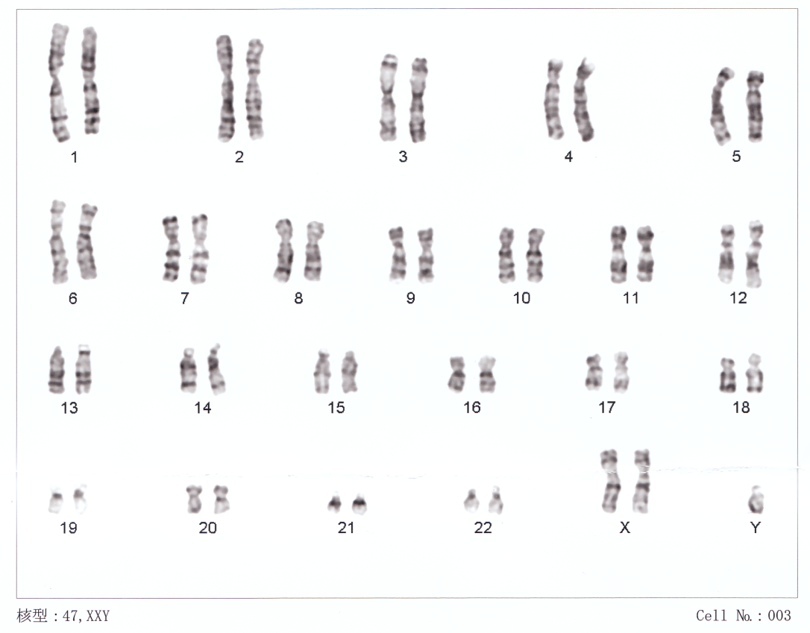
Fig.1 Eddies karyotype
Questions:
1. What is the diagnosis? Which group of genetic diseases belongs to this condition?
2. What is the epidemiology and prevalence rate of syndrome?
3. Write the probable mechanism of mutations in this disease in general.
4. How the phenotypic severity of this syndrome correlated with the type of mutation?
5. Propose methods of diagnosis, prevention and treatment of this disease in general and explain your strategy.

Option 15.
Luisa, a 14-year-old girl, was referred to the endocrinology clinic for evaluation of absent secondary sexual characteristics (menses and breast development). Although born small for gestational age, she had been in good health and had normal intellect. No other family members had similar problems. Her examination was normal except for short stature, Tanner stage I sexual development, and broad chest with widely spaced nipples. After briefly discussing causes of short stature and delayed or absent sexual development, her physician requested follicle-stimulating hormone (FSH) level, growth hormone (GHJ level, bone age study, and chromosome analysis. These tests showed a normal GH level, an elevated FSH level, and an abnormal karyotype (45,X). The physician explained that Luisa had Turner syndrome. Luisa was treated with GH supplements to maximize her linear growth; 1 year later, she started estrogen and progesterone therapy to induce the development of secondary sexual characteristics.
Questions:
1. What group of genetic diseases does this condition have?
2. What is the epidemiology and prevalence rate of this disorder?
3. Write the probable mechanism of mutations for these types of diseases.
4. How the phenotypic severity of this syndrome correlated with the type of mutation?
5. Propose method of Turner’s syndrome treatment and explain your strategy.

Final exam questions for Medical Microbiology

- Characterize main pathogenic types of gram-positive cocci, their properties and differentiate the pathogenic factors of staphylococcus and streptococcus in the development of pathological conditions.
- Differentiate the features of microbiological diagnosis in connection with the pathogenesis of caused diseases by gram-negative cocci. Specify principles of treatment and prevention.
- Differentiate pathogens of zoonotic infections by the level of epidemicity and severity, describe the pathogenesis of diseases.
- Explain the concept of quarantine infections and the rules of the anti-epidemic regime in the occurrence and development of anthrax and plague.
- Differentiate causative agents of diphtheria and pertussis in the development of diseases of the upper respiratory tract and describe the relationship between symptoms and toxin damage.
- Differentiate pathogenic and opportunistic mycobacteria. Explain the pathogenesis of tuberculosis. Describe the features of microbiological diagnosis in connection with the pathogenesis of diseases.
- Differentiate causative agent of sexually transmitted diseases by clinical manifestations and consequences, explain pathogenesis of the development of the disease.
- Differences in the pathogenesis of anaerobic infections caused by spore forming and non spore forming anaerobes. Specify the effect of pathogenicity factors such as enzymes, endo-and exotoxins, and non-specific metabolic factors.
- Describe the role of hepatitis and herpes viruses in the development of AIDS.
- Describe the differences in the pathogenicity of poliovirus depending on the serotype and explain principles of laboratory diagnosis.
- Differentiate the pathogenicity of the human herpes virus and the herpes simplex virus by the tropicity and severity of the disease and describe principles of prevention and treatment of herpetic infections.
- Differentiate causative agents of hepatitis by way of a transmission and form of the disease and describe principles of laboratory diagnosis.
Final exam questions for Pharmacology
1. A patient has acute drug poisoning. In the complex treatment, he was prescribed a drug that acts on the loop of Henle, it relates to a fast-acting diuretic. The patient developed hypokalemia. Name the drug

● Explain the mechanism of action of the drug.
● Explain the mechanism of side effects of the drug.
● List additional medicines that may help with this condition.
2. Prescribe these drugs:
1) Adrenaline
2) Gliclazide
3) Losartan

2. A patient with severe pain caused by a broken leg was injected with a strong natural analgesic, which cases addiction quickly, constrict the pupil, and depress the respiratory center. The patient developed nausea, bradycardia, dizziness, hypotension, constipation. What drug was used?
● Explain the mechanism of the drug's side effects.
● To which subgroup does the drug belong due to the mechanism of action?
● What drug can be used to replace it? Explain your answer.
2. Prescribe these drugs:
1) Metformin
2) Isoniazid
3) Pioglitazone

3. What antipyretic drug is prescribed if the patient has an acute respiratory viral infection? It suppresses the production of cyclooxygenase, irreversibly reduces platelet aggregation.
● Explain the mechanism of antiplatelet action. List the drugs that can replace this drug.
● What side effects can it cause in children?
● What are the indications to the drug?
2. Prescribe these drugs:
1) Enalapril
2) Acetylsalicylic acid
3) Spironolactone

4. When examining the child, the doctor notes a delay in the growth of teeth and their yellowing. After a conversation with the child's mother, it were revealed that the child has been treated with antibiotics for an intestinal infection for a long time. What antibiotic caused these complications?

● Explain how the side effects are related to the mechanism of action of the drug.
● Name a drug from the macrolide group. Compare the mechanism of action of macrolides and antibiotics from a clinical case.
● Describe side effects of these groups of antibiotics.
2. Prescribe these drugs:
1) Acyclovir
2) Morphine
3) Insulin (Actrapid)

5. The drug lowers blood pressure, affects the renin-angiotensin system, reduces the tone of the sympathetic nervous system, and dilates peripheral vessels. Side effects include dry cough and hyperkaliemia.

● Explain the mechanism of action of the drug.
● Explain the mechanism of the drug's side effects.
● List any additional drugs that can replace this drug.
2. Prescribe these drugs:
1) Furosemide
2) Metformin
3) Diclofenac

6. The drug is used for anaphylactic shock, bronchospasm. Increases heart rate and blood pressure, has no anti-inflammatory effect. It can be administered intravenously, intramuscularly, subcutaneously, in combination with local anesthetics.

● Define the drug and its pharmacological group.
● Describe the main effects of the drug.
● Describe the side effects of the drug.
2. Prescribe these drugs:
1) Dexamethasone
2) Amoxicillin
3) Doxycycline

7. The patient is prescribed a drug for the treatment of bronchospasm. The drug reduces the tone of the uterus in pregnant women, is administered only by inhalation, and acts quickly. Rarely can increase heart rate, does not increase blood pressure.

● Define the drug and its pharmacological group.
● Describe the mechanism of action of the drug.
● Describe the side effects of the drug.
2. Prescribe these drugs:
1) Adrenaline
2) Metronidazole
3) Ciprofloxacin

8. A synthetic drug is used for all types of tuberculosis, has a high activity, narrow spectrum of action, high toxicity.
● Define the drug and its pharmacological group.
● What anti-TB drugs can it be combined with and what is the purpose of this combination?
● Describe the side effects of the drug. What can be prescribed to a patient to reduce side effects on the central nervous system.
2. Prescribe these drugs:
1) Warfarin
2) Fluconazole
3) Vancomycin

9. A 60-year-old patient was admitted to the clinic with a diagnosis of myocardial infarction. The patient can be prescribed: 1) subcutaneous morphine solution 2) intravenous streptokinase solution 3) Warfarin, tablets.
● What drug should not be prescribed in this case? Explain the reason for the ineffectiveness of the drug.
● Describe the mechanism of action of the selected drug.
● Give a comparative description of the streptokinase and warfarin.
2. Prescribe these drugs:
1) Norepinephrine
2) Hydrochlorothiazide
3) Prazosin

10. A 65-year-old woman with type 2 diabetes mellitus and impaired peripheral circulation should be prescribed a hypoglycemic drug that suppresses platelet aggregation, which has a high degree of binding to blood plasma proteins, the maximum concentration is observed after 2-6 hours.
● What drug should be prescribed? Justify your answer.
● The mechanism of action of the drug.
● Compare the side effects of this drug and of Metformin.
2. Prescribe these drugs:
1) Nifedipine
2) Metoprolol
3) Azithromycin

